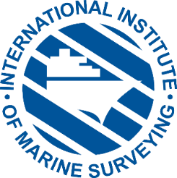
IIMS 2022 Safety & Loss Prevention Briefings Compendium published
Press information
November 2022
For immediate release
March 2020

Following the surprise runaway success of the first edition of the Safety & Loss Prevention Briefings Compendium, published in January 2022 by the International Institute of Marine Surveying (IIMS), and subsequently downloaded many thousands of times, Edition II has been launched covering the period January to October 2022. It is now available to download and read in pdf or eReader formats.
Edition II builds on the success of the launch publication and extends to 160 pages. The simple aim is to highlight the dangers of working in the maritime industry, the ensuing accidents and some of the prevention measures available to mitigate disasters at sea. The publication blends a mix of incident and accident reports with essential loss prevention advice generated over the year. One significant new feature is a calendar, featuring some of the many accidents that have occurred during 2022, catalogued month by month.
Editor, Mike Schwarz, said, “On the face of it there have been few major accidents hitting the media headlines resulting in excessive loss of life in 2022 compared to previous years - on the face of it! Yet there have still been far too many unfortunate deaths at sea and marine assets destroyed, many of them seemingly avoidable.”
Stuart Edmonston, Loss Prevention Director, UK P&I Club, author of the Compendium’s main introduction said, “As loss prevention director at one of the world’s leading P&I clubs, it’s always tough to read maritime accident reports - particularly when people have tragically lost their lives or suffered life-changing injuries. It’s even tougher when, as in most of cases, the accidents could have been prevented if the ships and people involved had been better prepared.”
In his introduction, IIMS President, Peter Broad, said, “The first Compendium certainly reached a very wide audience, way beyond the marine surveying community itself, and makes sobering reading when we see all these ‘incidents and accidents’ together in one concise document.”
The Compendium can be read in pdf format at https://bit.ly/3GpsbEr and/or in eReader format at http://bit.ly/3XawqcW. Or scan the QR code.

Ends.

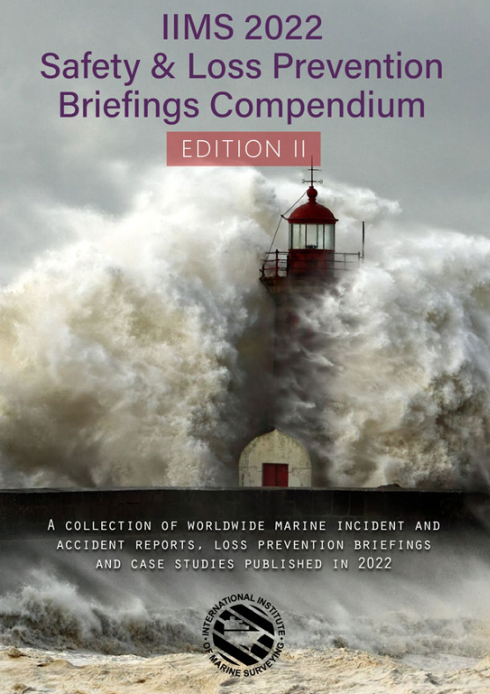

Note to editors:
About IIMS
Formed in 1991, the International Institute of Marine Surveying is a not-for-profit organisation and the leading worldwide professional body for marine surveyors with a membership of one thousand surveyors in over one hundred countries.
For further information
Mike Schwarz
IIMS Chief Executive Officer
Email: info@iims.org.uk
Web: www.iims.org.uk

